WEEK-10 Elasticbeanstalk

Prerequisites
- A web application ready (e.g., .war, .zip, or code)

Steps to Create Elastic Beanstalk Application
Step 1: Open Elastic Beanstalk
- Login to AWS Console
- Under Compute section ->Search for Elastic Beanstalk
- 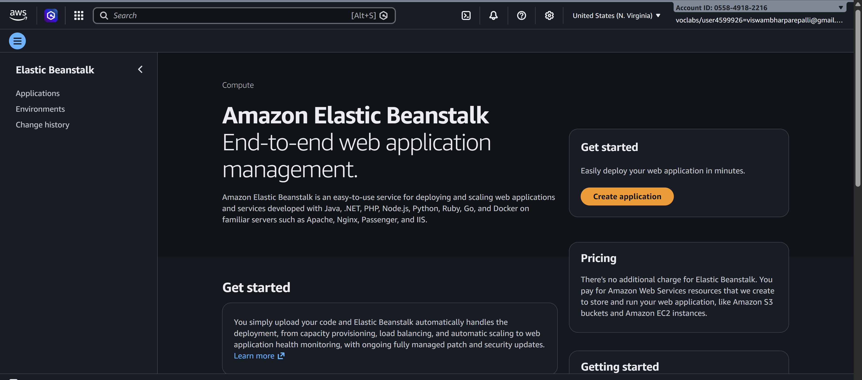
- Click Create Application

Step 2: Create Application
- Enter Application Name (e.g., MyApp)
- Add description (optional)
- Click Create
- 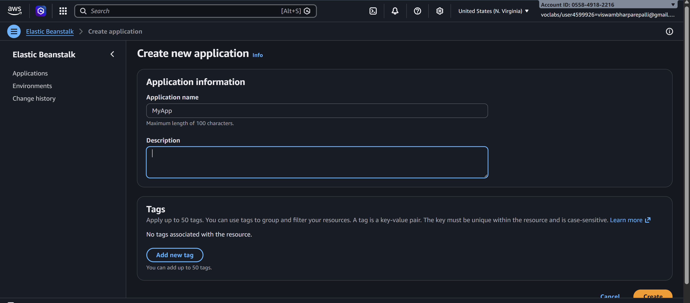

Step 3: Create Environment
- Click Create Environment
- Choose:
  - Web Server Environment (for web apps)
- Click Select
- 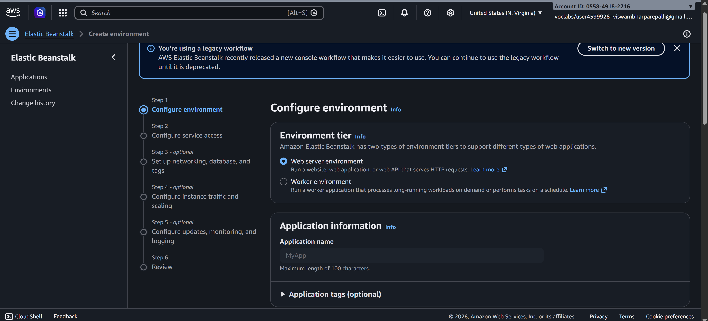

Step 4: Configure Environment
- Enter Environment Name
- Choose Platform:
  - tomcat (for .war)
  - tomcat /Node.js / Python / PHP / etc.
  - 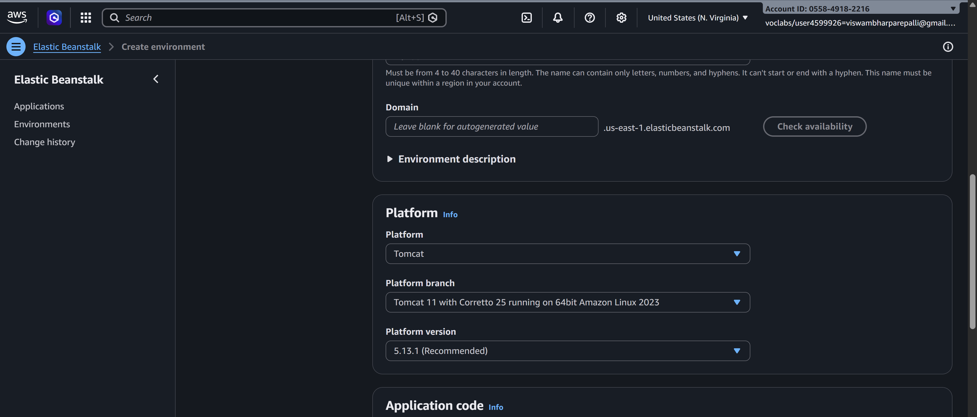
- Under Application Code:
  - Select Upload your code
  - Upload your .war or .zip file
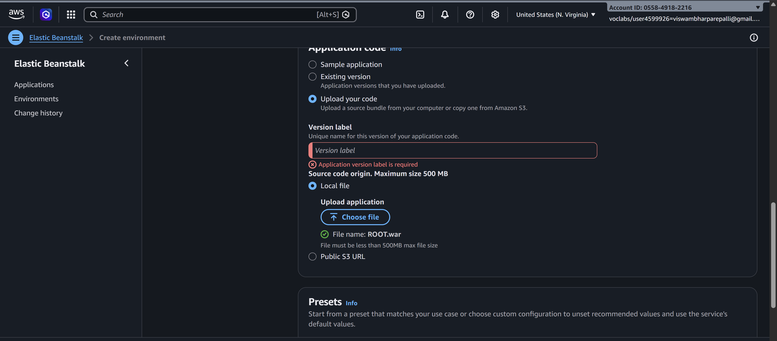
Step 5: Configure Service Access
- Service Role → Select existing -LabRole
- EC2 Key Pair → Optional (for SSH)
- EC2 Instance Profile → select (e.g., LabInstanceProfile)
- 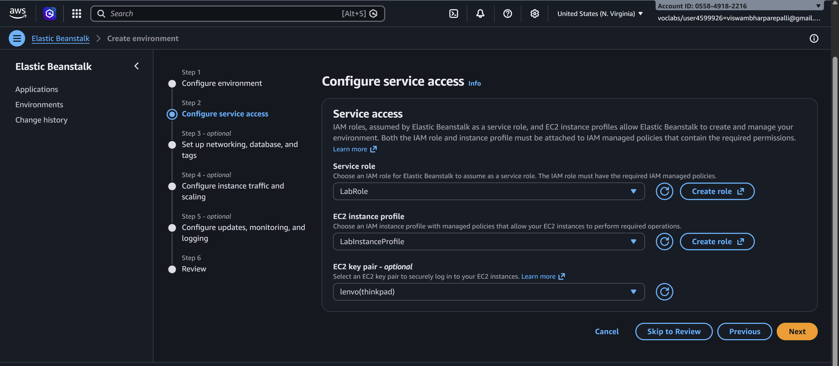

Step 6: Configure Network
- Select VPC (default is fine)
- Select Subnets
- Enable Public IP
- 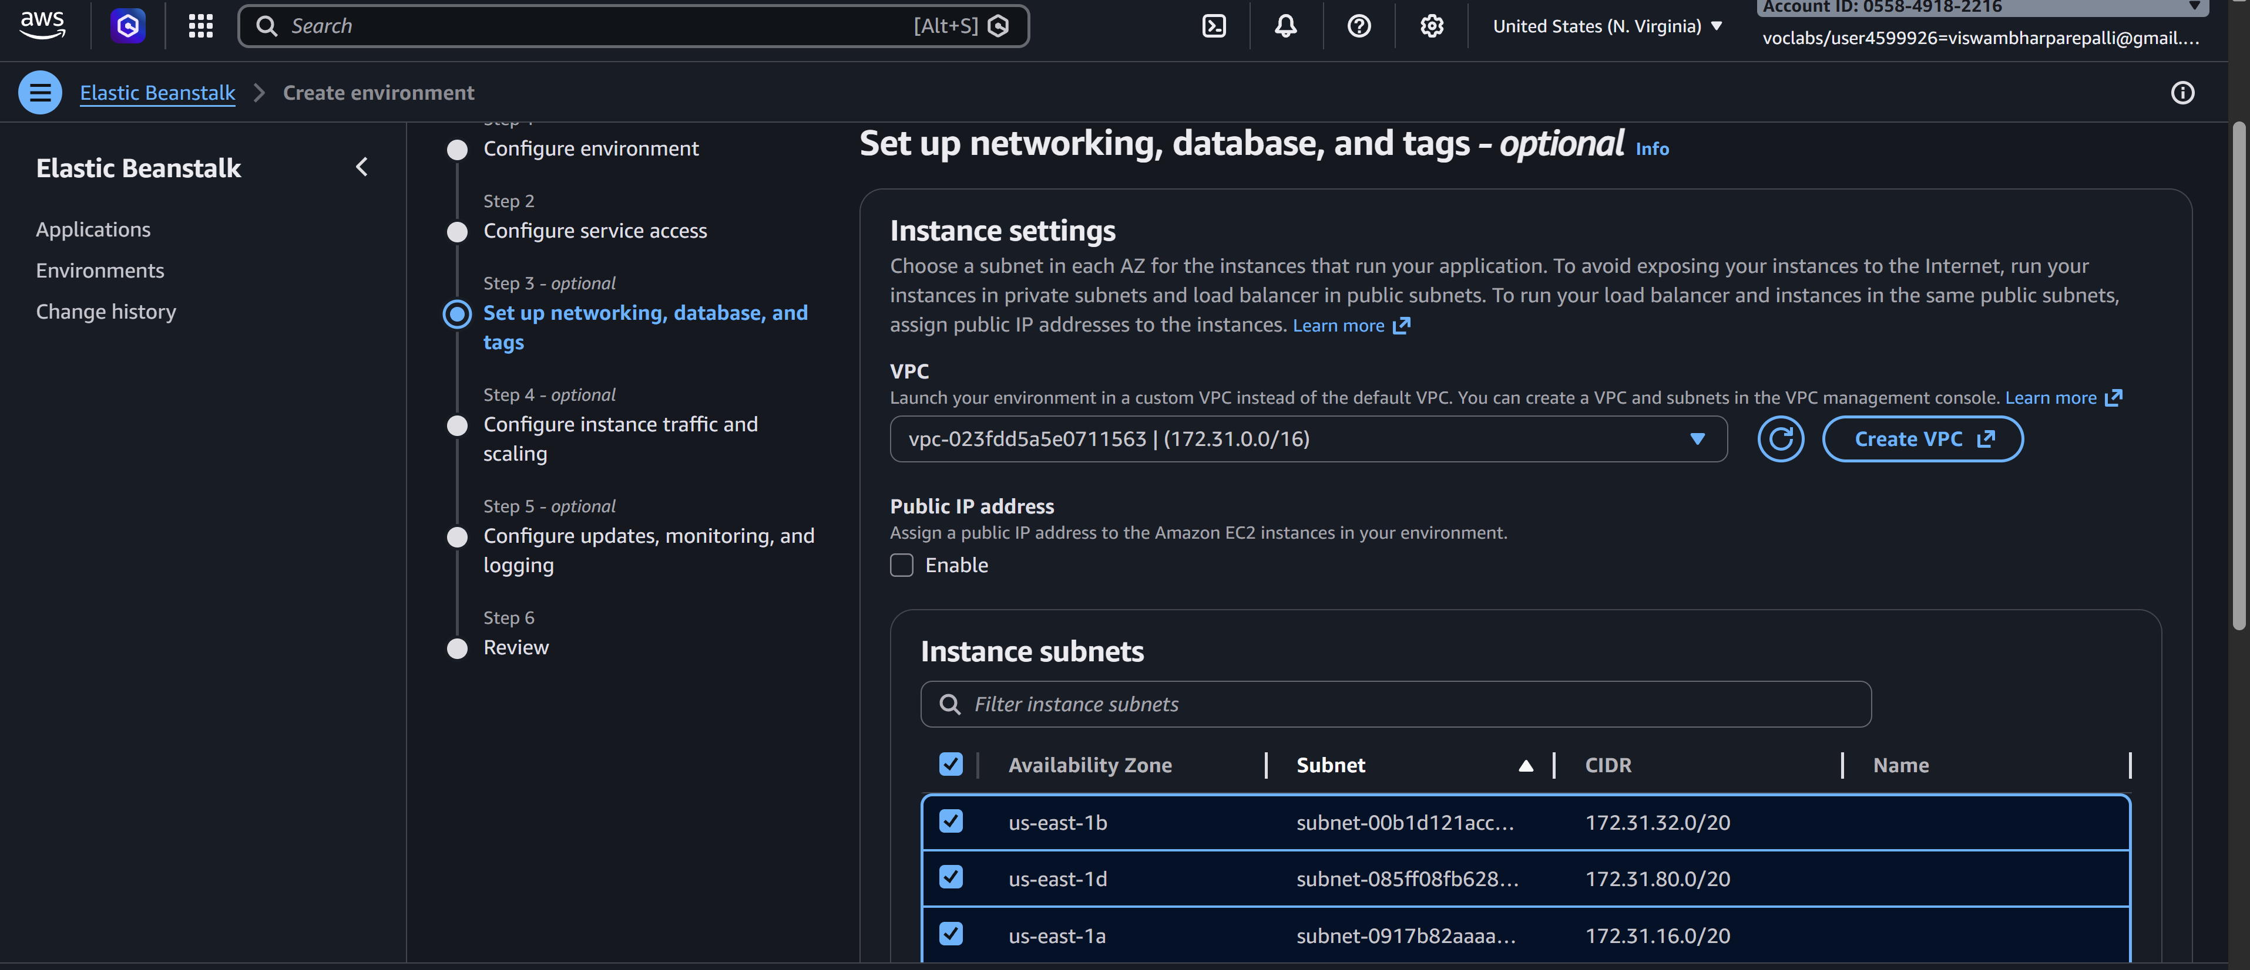

Step 7: Instance & Scaling Setup
- Choose Instance type (e.g., t2.micro – free tier)
- Set:
  - Min instances: 1
  - Max instances: 2 (or more)
- Load Balancer → Enabled (optional but recommended)
- 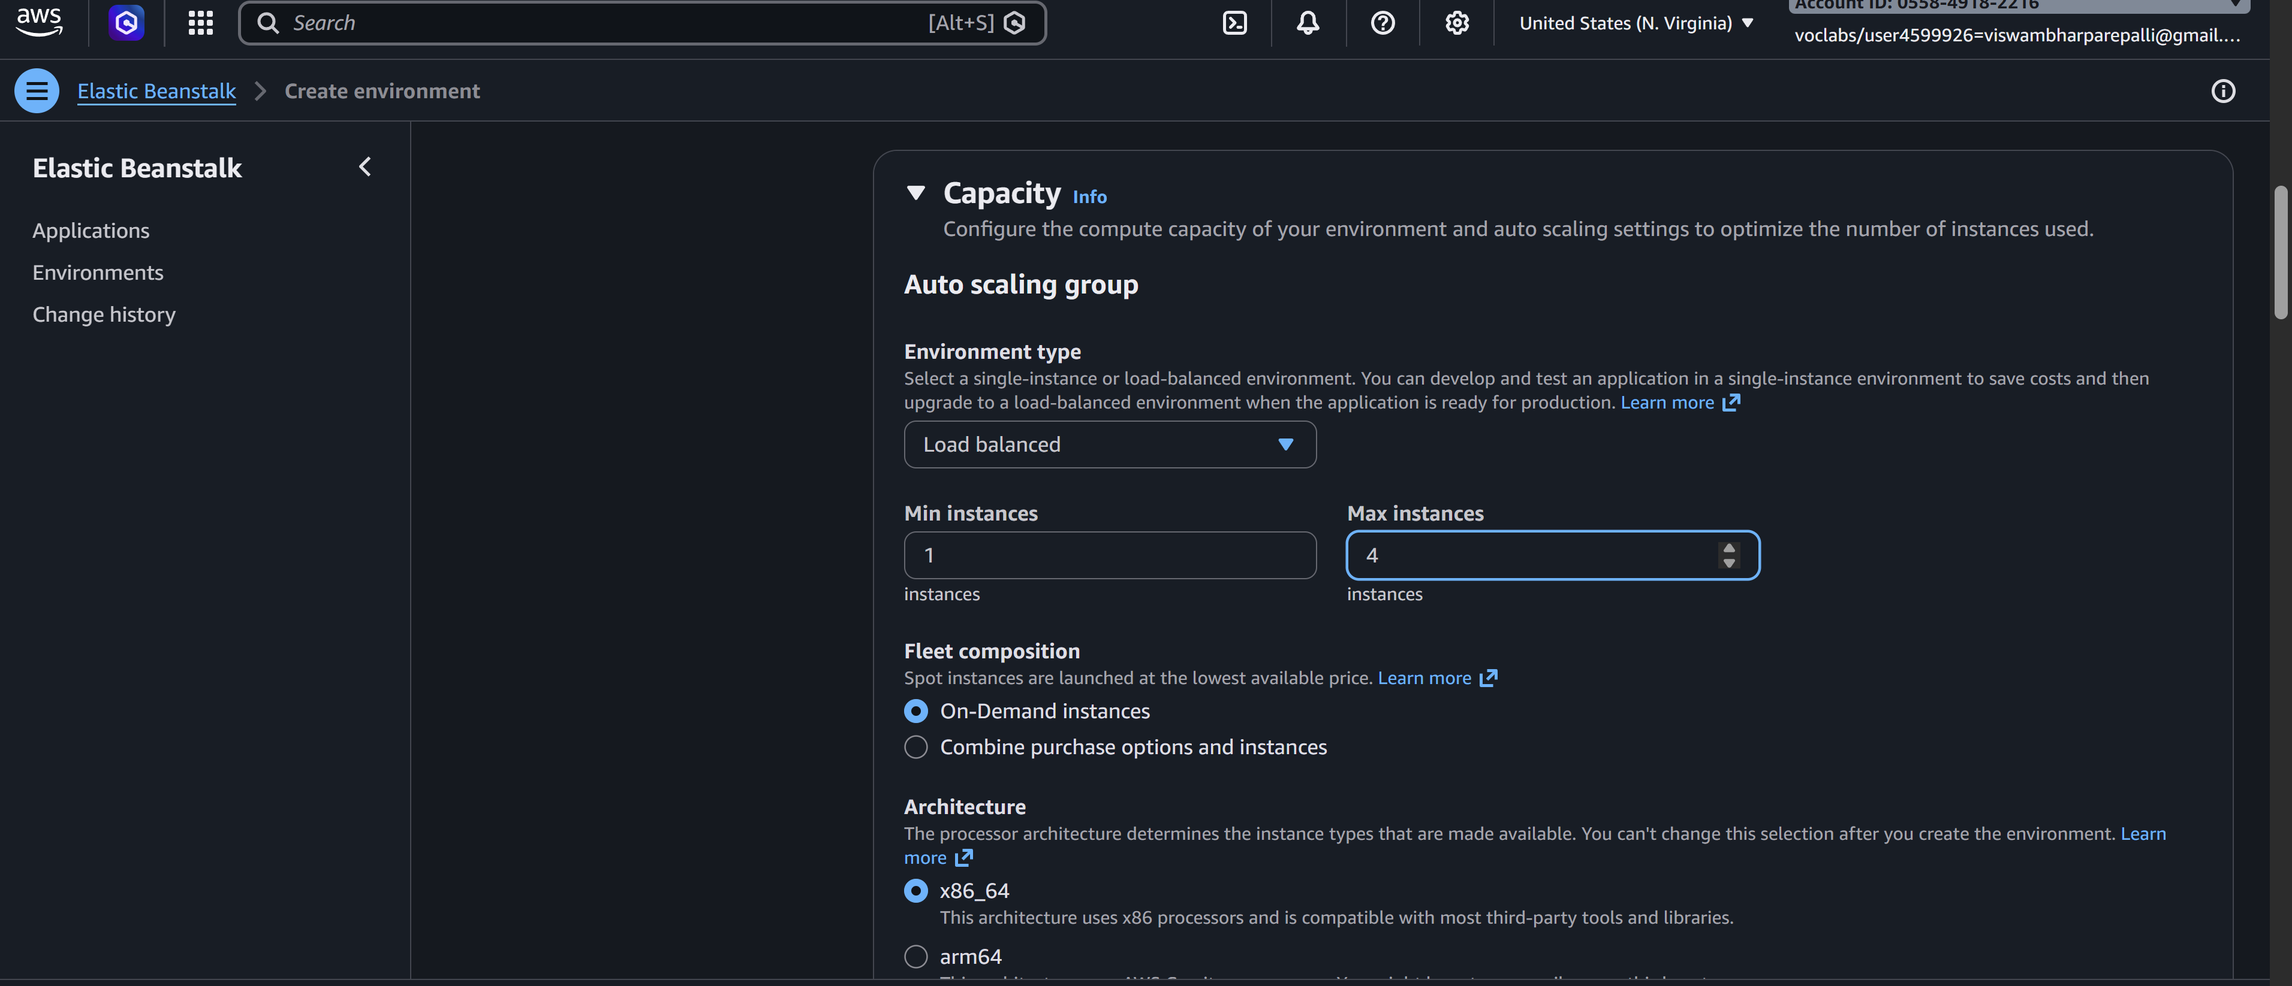

Step 8: Review & Create
- Click Review
- Click Create
- 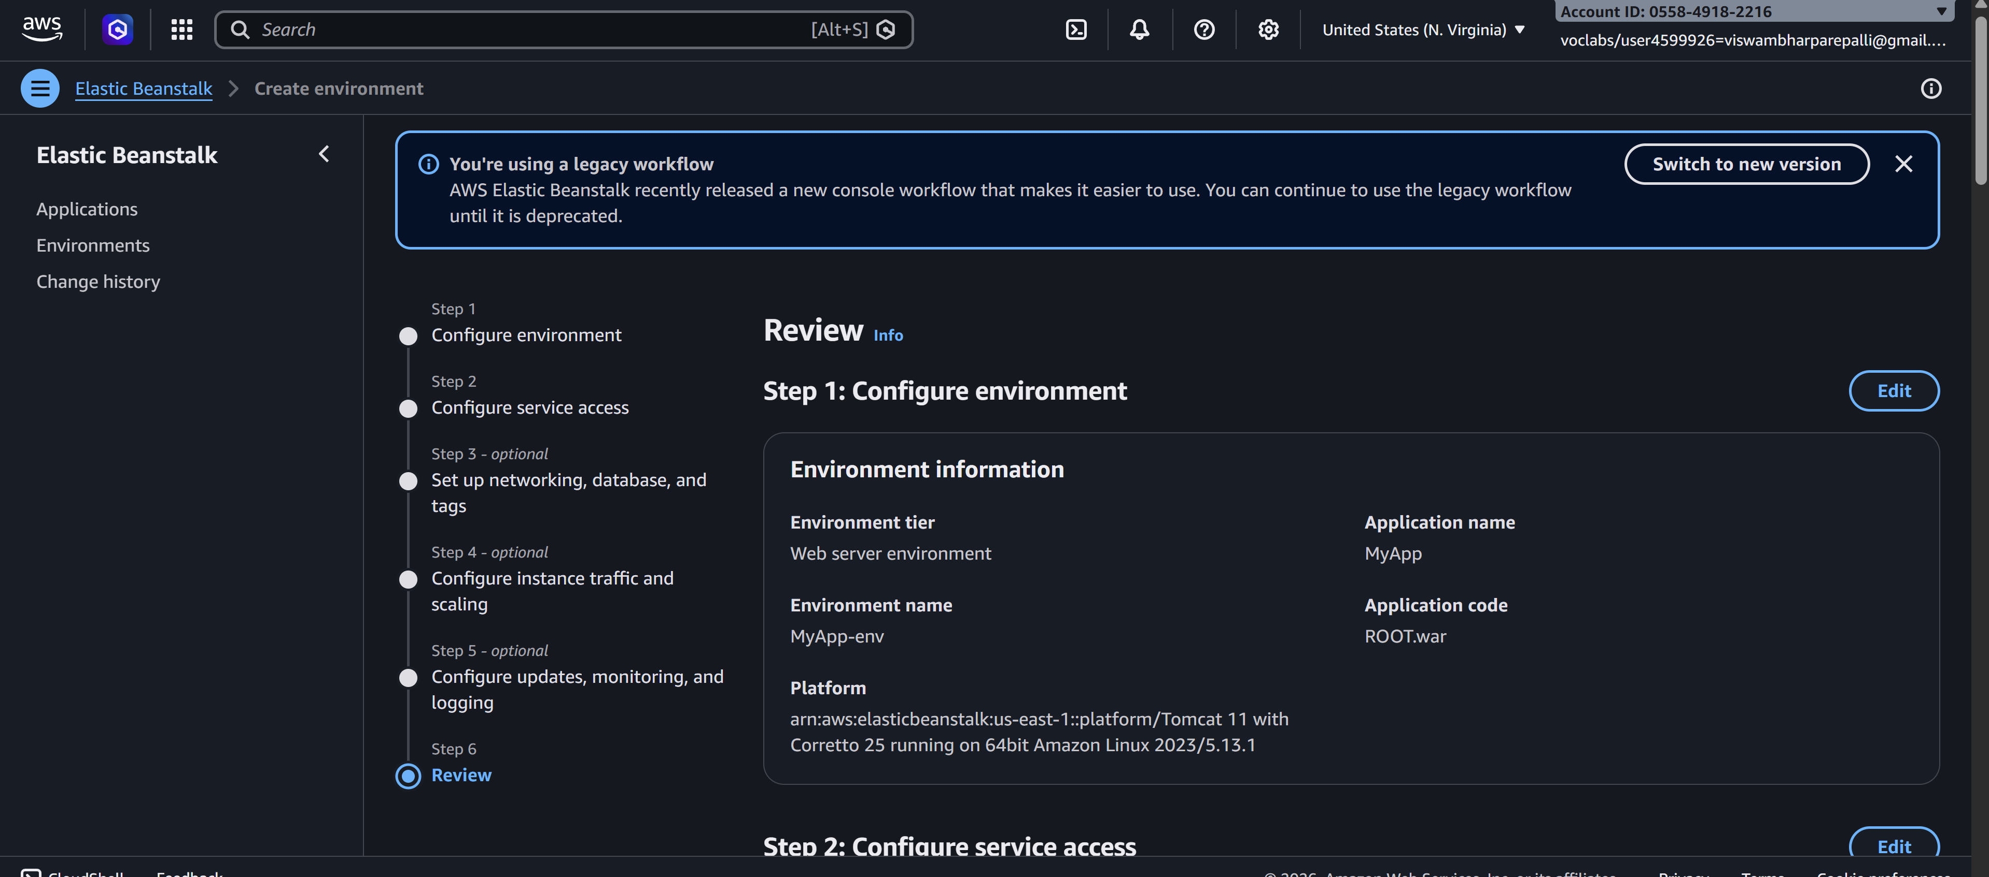

Deployment Process
- AWS automatically creates:
  - EC2 instances
  - Load Balancer
  - Auto Scaling Group
  - Security Groups
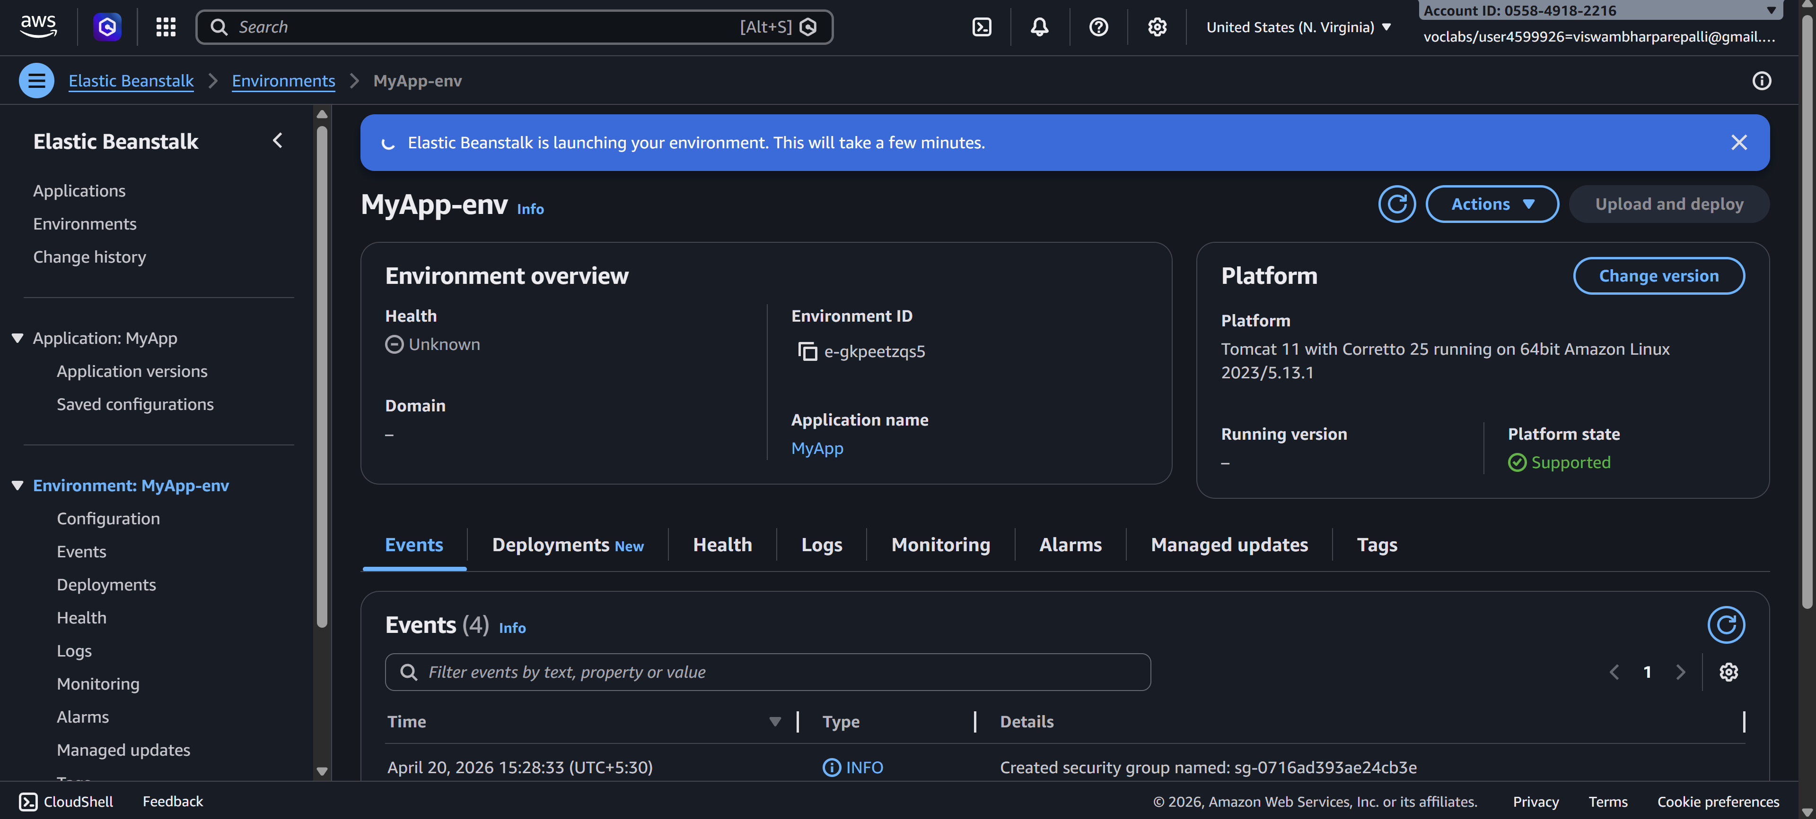
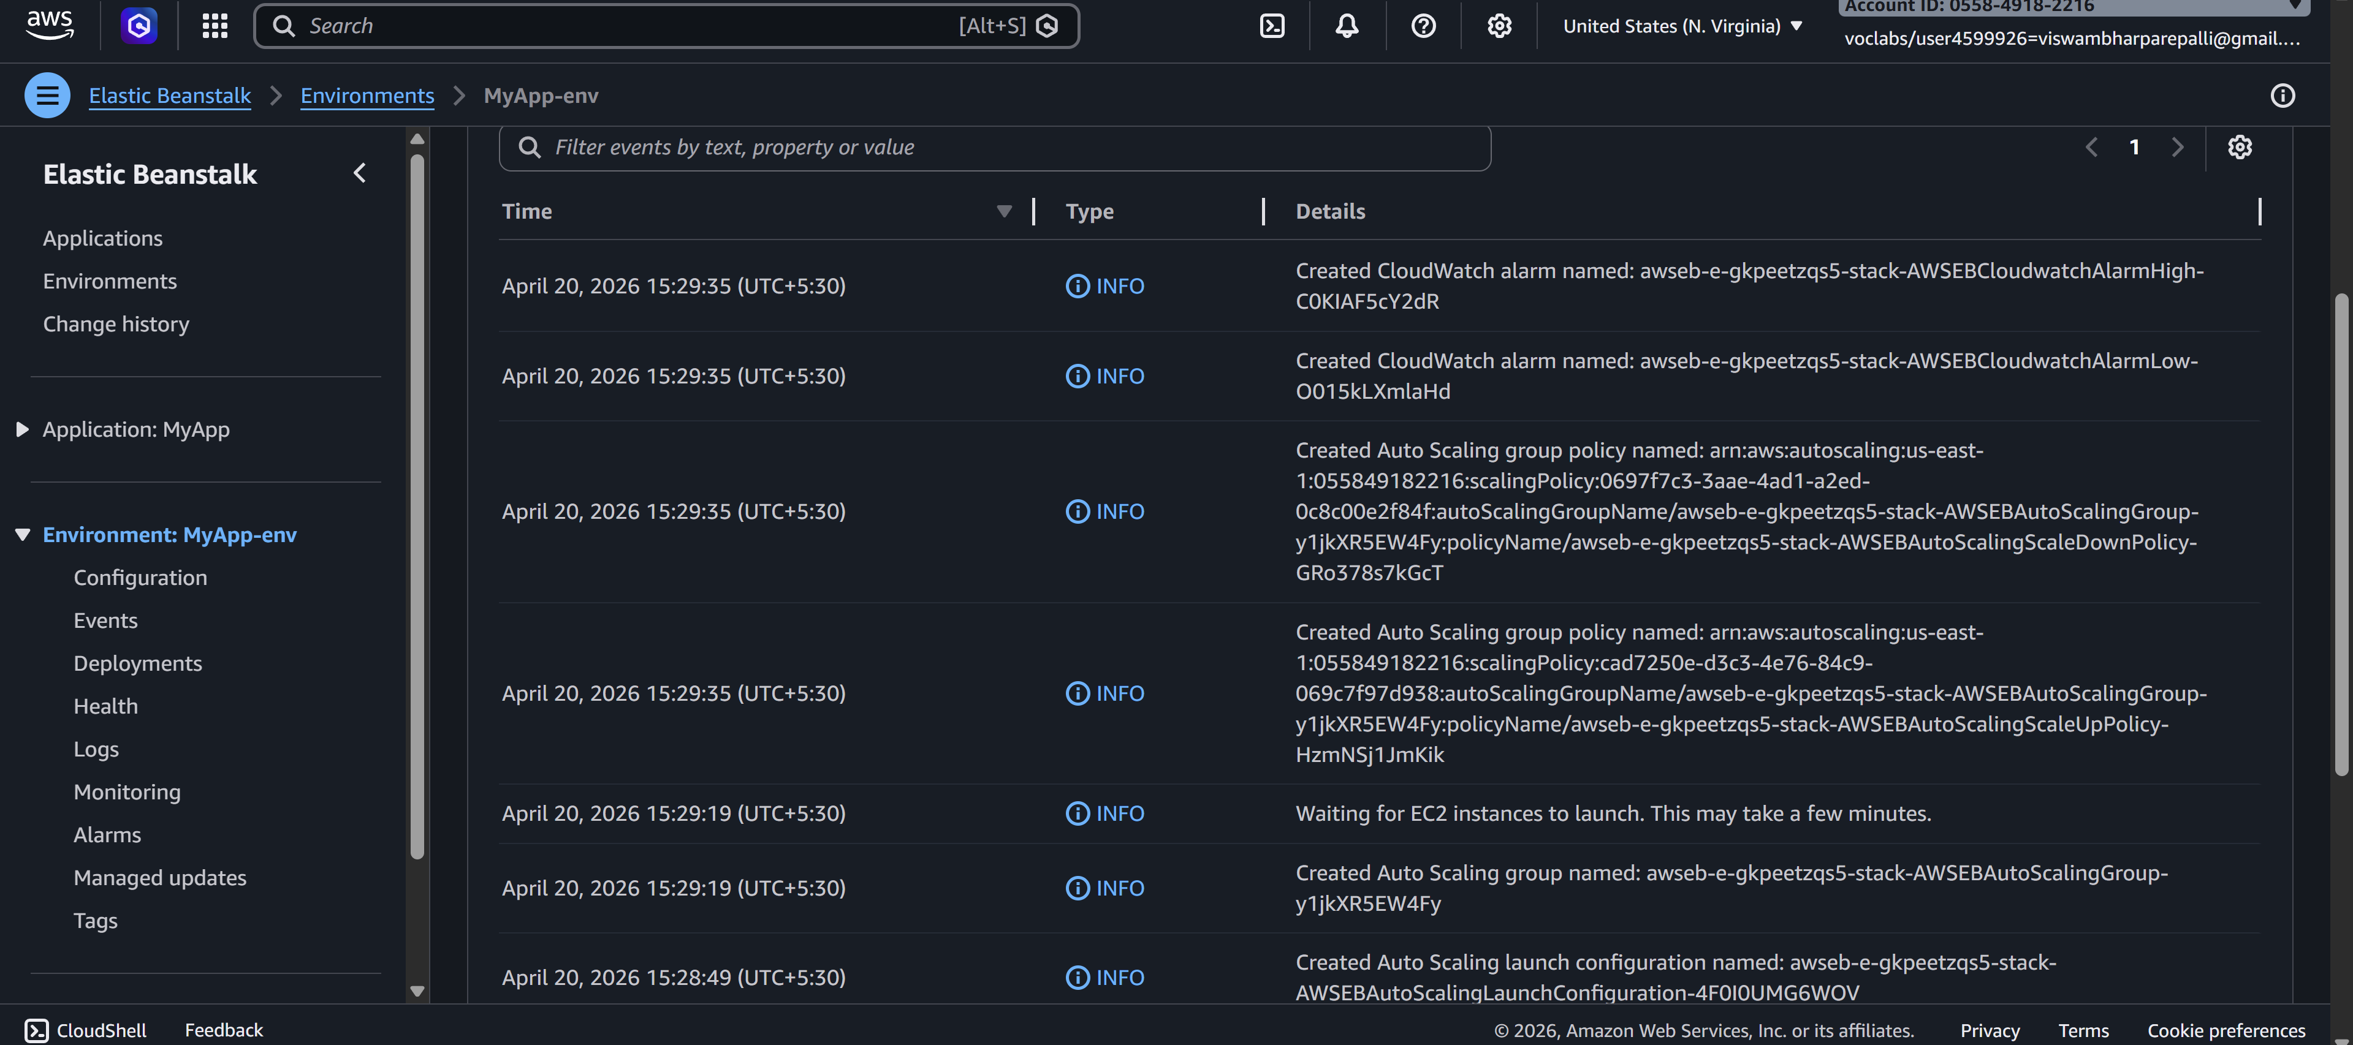

Access Your Application
- After deployment:
  - You will get a URL (domain link)
  - Open it in browser → Your app will run
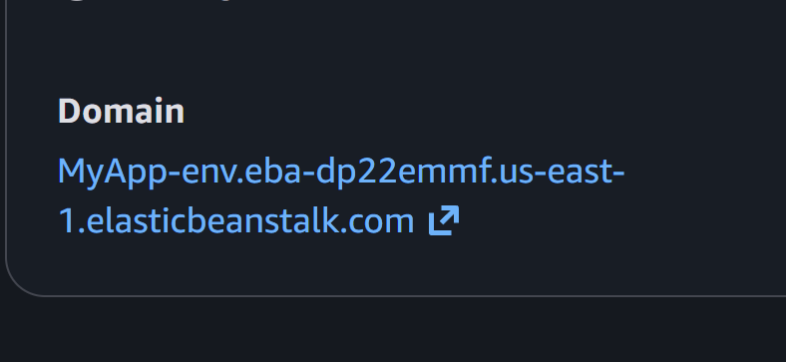
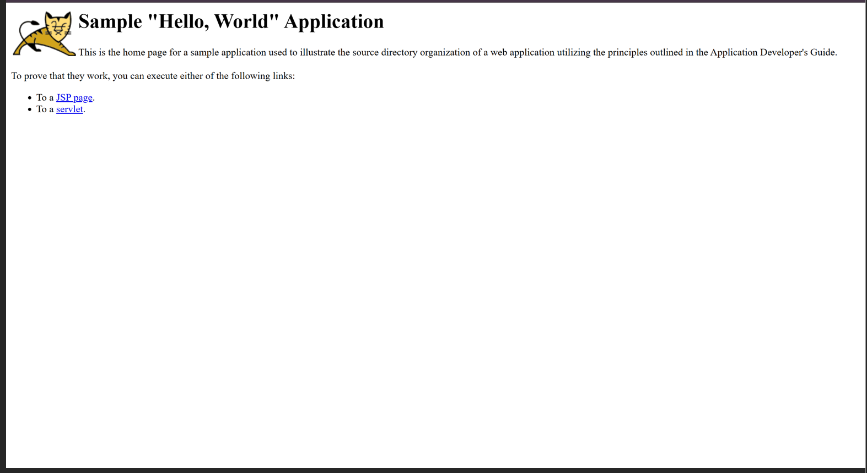

Updating Application
- Go to your environment
- Click Upload and Deploy
- Upload new version
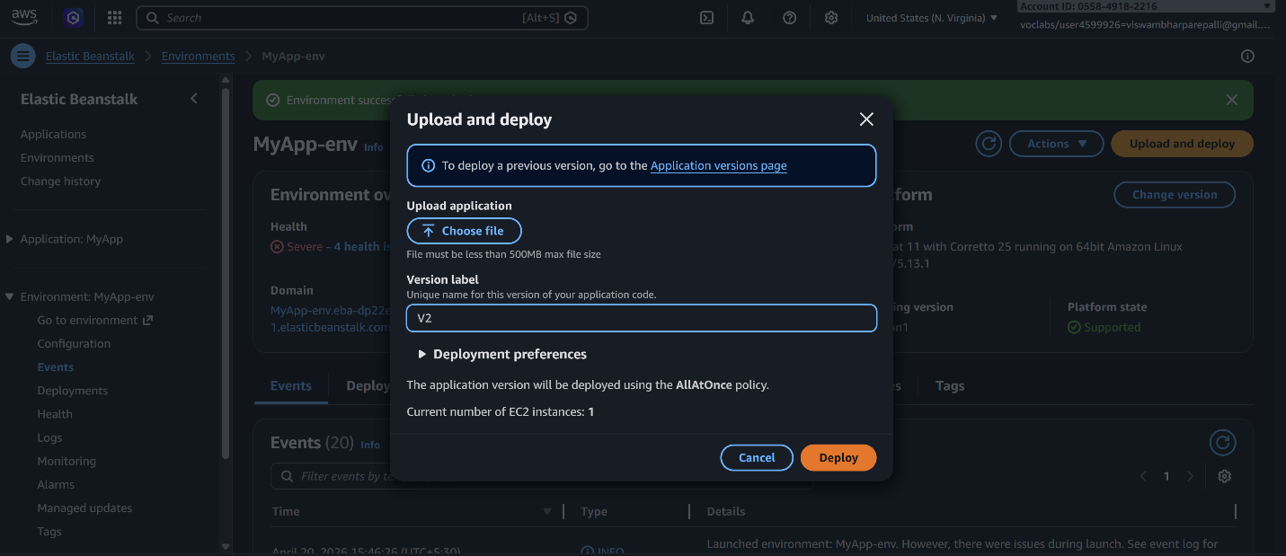
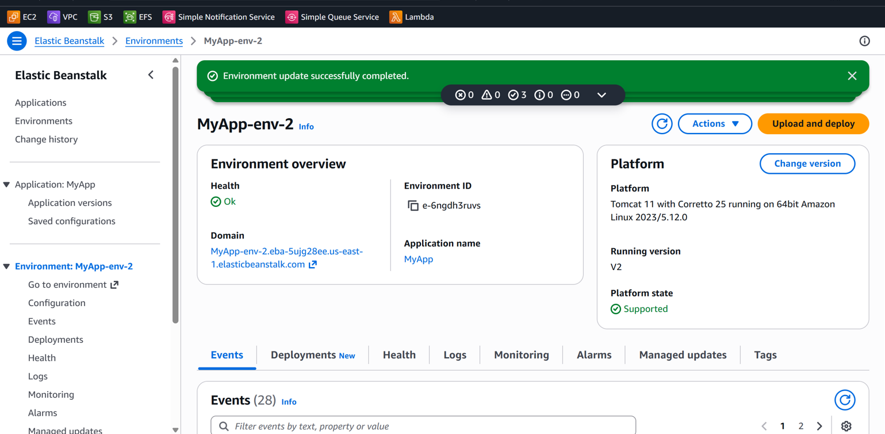

Scenario-Based Questions
Scenario 1: Application Not Loading
You deployed an application using Elastic Beanstalk, but the application does not load and shows an error page.
- What could be the possible reasons for this issue?
- Could deployment or configuration be incorrect?
- How would you troubleshoot this problem?

Scenario 2: Incorrect Application Structure
Your application is deployed, but the expected output is not displayed.
- How does application structure affect deployment in Elastic Beanstalk?
- What could happen if files are placed inside an extra folder?
- How would you fix the structure issue?

Scenario 3: Wrong Platform Selection
While creating the environment, an incorrect platform was selected.
- Why is platform selection important in Elastic Beanstalk?
- What kind of errors or behavior might occur?
- How can you correct the platform without affecting the application?

Scenario 4: Environment Health Warning
The environment status shows Warning (Yellow) instead of healthy.
- What are possible reasons for this warning?
- Which sections (Events, Logs, Metrics) would you check first?
- How can you resolve health issues?

Scenario 5: Application Errors in Logs
Logs show a high number of application errors.
- What do such errors indicate?
- Could this be due to misconfiguration or missing resources?
- How would you analyze logs to identify the root cause?

Scenario 6: Deployment Failure
The application deployment fails during upload.
- What could be wrong with the deployment package?
- Which logs would you check to diagnose the issue?
- How can packaging errors affect deployment?

Scenario 7: Works Locally but Not on Cloud
The application works correctly on a local machine but fails after deployment.
- What environment differences could cause this issue?
- Could configuration or dependency issues be responsible?
- How would you debug using cloud logs?

Scenario 8: Blank Output
The application loads but shows no output.
- What could cause an application to display no output?
- Could runtime errors or misconfigurations be responsible?
- How would logs help in identifying the issue?

Scenario 9: Application URL Not Accessible
The application URL is not accessible after deployment.
- Could the environment still be launching?
- What status indicators should be checked?
- How can Events help identify the issue?

Scenario 10: Resource Management Issue
After completing the lab, resources were not terminated.
- What are the cost implications of leaving resources running?
- Which AWS services continue running in the background?
- How can all resources be properly terminated?

Scenario 11: High Traffic Handling
The application receives sudden high traffic.
- How does Elastic Beanstalk handle scaling?
- What configurations should be enabled?
- What happens if scaling is not configured?

Scenario 12: Application Update Not Reflected
Changes are made to the application, but users still see the old version.
- Could deployment issues be the reason?
- How can caching affect the output?
- How would you ensure the latest version is visible?

